

Solar On Grid Proposal for

# {customerName}

System Capacity: {netCapacity}KW ON-Grid Solar Project

**Site Details:-**

| Site Address | {customerAddress} | | |
| --- | --- | --- | --- |
| Haryana, India | | |
| Building Type | {connectionType} | Roof Type | {roofType} |
| Contact No. | {contactNo} | Email ID | {contactEmail} |

**Electricity Board & Load Details:-**

| Consumer Type | {connectionType} | Connection Type | {phase} |
| --- | --- | --- | --- |
| Sanction Load | {connectedLoad}KW | Average Monthly Bill | 5 K |
| Avg. Power Cut | 0.30 to 1 Hrs. | Electricity Board | UHBVN |

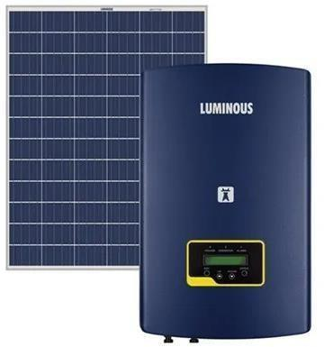



# Solution Packages - {netCapacity} KW ON Grid

| S. No | Component | Gold | | Package | |
| --- | --- | --- | --- | --- | --- |
| 1 | Solar PV Panel | {panelBrand} {panelType} {panelCapacity}Wp x  **{NoOfPanels} UNITS** (25 Yrs. Performance Warranty) | | | |
| 2 | Structure + Net Metering Connection | NOT INCLUDED + YES | | | |
| 3 | Solar GTI Inverter | {inverterBrand} ({inverterCapacity}KW ON GRID )  Inverter (8 Yrs. On-Site Warranty) | | | |
| 4 | ACDB & DCDB, BOS | IP65/55 enclosure box with SPD | | | |
| 5 | Earthing & PV Protection system, Civil Work | Copper bonded earthing & Franklin type L.A. | | | |
| 6 | Remote Monitoring System | Available (Wi-Fi) (optional) | | | |
| 7 | 🡺 DC Cables (Modules - Inverter)  🡺 AC Cables (Inverter - ACDB - Feeder / LT Panel) | 🡺 1 Core X 4 Sqmm Cu (Red & Black) POLYCAB  🡺 3.5 Core X 300 Sqmm aluminium armoured POLYCAB / Havells | | | |
| 8 | Insurance | Optional (If customer needs) | | | |
| 9 | Service Support | Yes, Onsite service support against break- down Call during the warranty period. | | | |
| 10 | Technical Support | Yes, 2 Years Technical Support from Date of Commissioning | | | |
| **COST of {netCapacity} KW Solar Power Plant** | | | | | |
| COST of 6 KW Solar Power Plant | | | **₹ {baseCost}/-** | | |
| **GST** | | | ₹ {tax}/- | | |
| **Total System Price (GST Included)** | | | **₹ {netCost}/-** | | |
| Advance Amount | | |  | | |
| 2nd Tranche Amount | | |  | |  |
| Final Tranche Amount | | |  | | |

**Payment Schedule**

| **S. No** | **Description** | **Package** |
| --- | --- | --- |
| 1 | Advance payment along with Purchase order | 35% |
| 2 | Payment against Performa Invoice | 60% |
| 3 | Before Material Dispatch | 5% |

| **Savings** | |
| --- | --- |
| Annual expected UNITS generation | {netCapacity}KW*4.5 UNITS*300DAYS= {units} UNITS |

### GENERAL TERMS & CONDITIONS:

**SERVICE WARRANTY TERM:**

**-> Solar Modules: -** 25 Years Manufacturers Performance Warranty.

**-> Solar Inverter: -** 02 Years Manufacturers Product Warranty (Extendable with extra cost).

**-> ACDB & DCDB: -** 01 Year Manufacturers Product Warranty.

**-> Work Man Ship: -** 02 Years. (No charge of service, only (if any) component is involved, cost to be borne by Customer With transportation Charges.

**-> Any damage** due to Wind, Cyclone or any other Natural Calamity does not covers under warranty.

### CUSTOMER RESPONSIBILITY:

->To provide neat and clean area to keep our Solar Material safe with lock and key facility or Security Guard.

-> To provide Electricity connection and Water.

->All initial and final drawing / SLD approvals.

-> Document support for any approval or Net Metering (If in our Scope).

-> Shut Down of complete electrical system at the time of Commissioning of Solar Power Plant.

-> Sign & Stamp on all Delivery Challan at the time of delivery of material.

-> A Manager Level Manpower shall be deputed for the all the correspondence and utility support.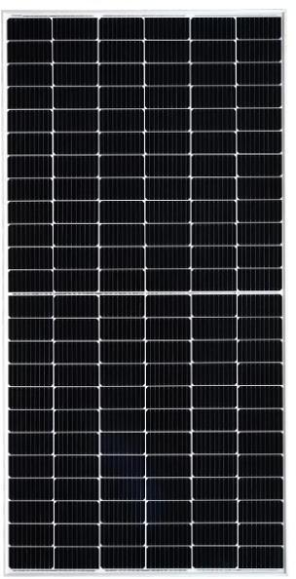

### AUTHORISATION:

Above information is provided with best of our knowledge and past experience. We also confirm that all particulars are true and correct.

**Bank Details – N D TECHNOSOLUTIONS**

**Bank Name – ICICI BANK A/C NO ( 086105003027 )**

**IFSC CODE – ICIC0000861**

**Auth: - Partner of Luminous**

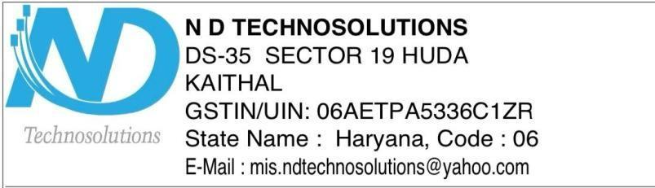

**Thanks & Regards:-**

## ND TECHNOSOLUTIONS